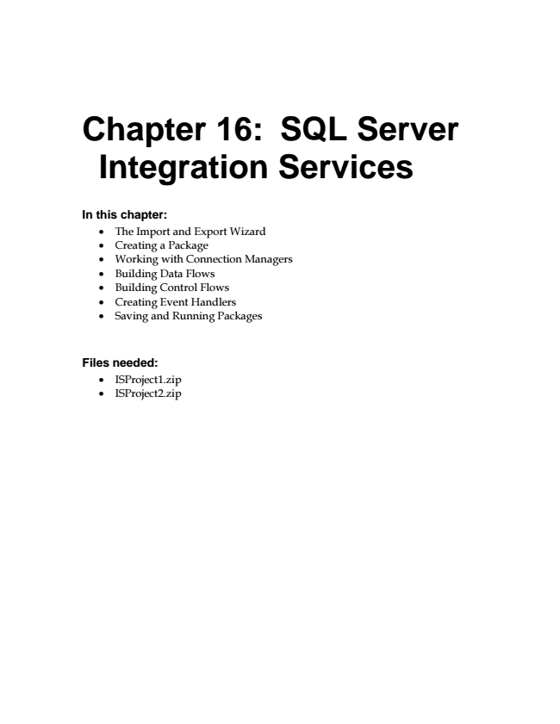

**Chapter 16: SQL Server**

**Integration Services**

**In this chapter:**

• The Import and Export Wizard

• Creating a Package

• Working with Connection Managers

• Building Data Flows

• Building Control Flows

• Creating Event Handlers

• Saving and Running Packages

**Files needed:**

• ISProject1.zip

• ISProject2.zip

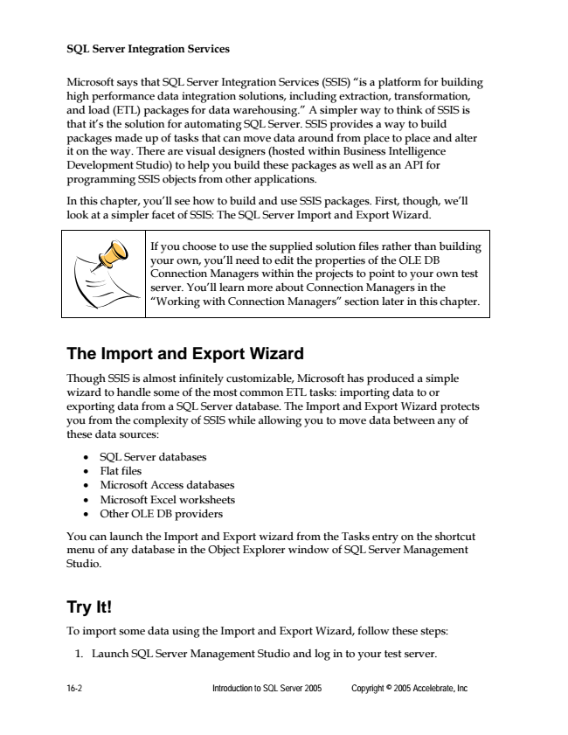

**SQL Server Integration Services**

Microsoft says that SQL Server Integration Services (SSIS) “is a platform for building high performance data integration solutions, including extraction, transformation, and load (ETL) packages for data warehousing.” A simpler way to think of SSIS is that it’s the solution for automating SQL Server. SSIS provides a way to build packages made up of tasks that can move data around from place to place and alter it on the way. There are visual designers (hosted within Business Intelligence Development Studio) to help you build these packages as well as an API for programming SSIS objects from other applications.

In this chapter, you’ll see how to build and use SSIS packages. First, though, we’ll look at a simpler facet of SSIS: The SQL Server Import and Export Wizard.

If you choose to use the supplied solution files rather than building your own, you’ll need to edit the properties of the OLE DB Connection Managers within the projects to point to your own test server. You’ll learn more about Connection Managers in the “Working with Connection Managers” section later in this chapter.

**The Import and Export Wizard**

Though SSIS is almost infinitely customizable, Microsoft has produced a simple wizard to handle some of the most common ETL tasks: importing data to or exporting data from a SQL Server database. The Import and Export Wizard protects you from the complexity of SSIS while allowing you to move data between any of these data sources:

• SQL Server databases

• Flat files

• Microsoft Access databases

• Microsoft Excel worksheets

• Other OLE DB providers

You can launch the Import and Export wizard from the Tasks entry on the shortcut menu of any database in the Object Explorer window of SQL Server Management Studio.

**Try It!**

To import some data using the Import and Export Wizard, follow these steps:

1. Launch SQL Server Management Studio and log in to your test server.

16-2 Introduction to SQL Server 2005 Copyright © 2005 Accelebrate, Inc

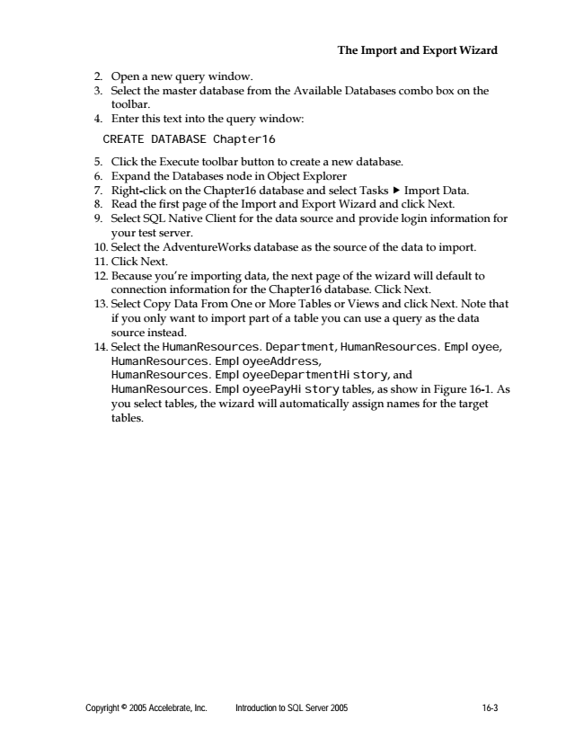

**The Import and Export Wizard**

2. Open a new query window. 3. Select the master database from the Available Databases combo box on the

toolbar. 4. Enter this text into the query window:

CREATE DATABASE Chapter16

5. Click the Execute toolbar button to create a new database. 6. Expand the Databases node in Object Explorer 7. Right-click on the Chapter16 database and select Tasks ► Import Data. 8. Read the first page of the Import and Export Wizard and click Next. 9. Select SQL Native Client for the data source and provide login information for

your test server. 10. Select the AdventureWorks database as the source of the data to import. 11. Click Next. 12. Because you’re importing data, the next page of the wizard will default to

connection information for the Chapter16 database. Click Next. 13. Select Copy Data From One or More Tables or Views and click Next. Note that

if you only want to import part of a table you can use a query as the data source instead. 14. Select the HumanResources.Department, HumanResources.Employee,

HumanResources.EmployeeAddress, HumanResources.EmployeeDepartmentHistory, and HumanResources.EmployeePayHistory tables, as show in Figure 16-1. As you select tables, the wizard will automatically assign names for the target tables.

Copyright © 2005 Accelebrate, Inc. Introduction to SQL Server 2005 16-3

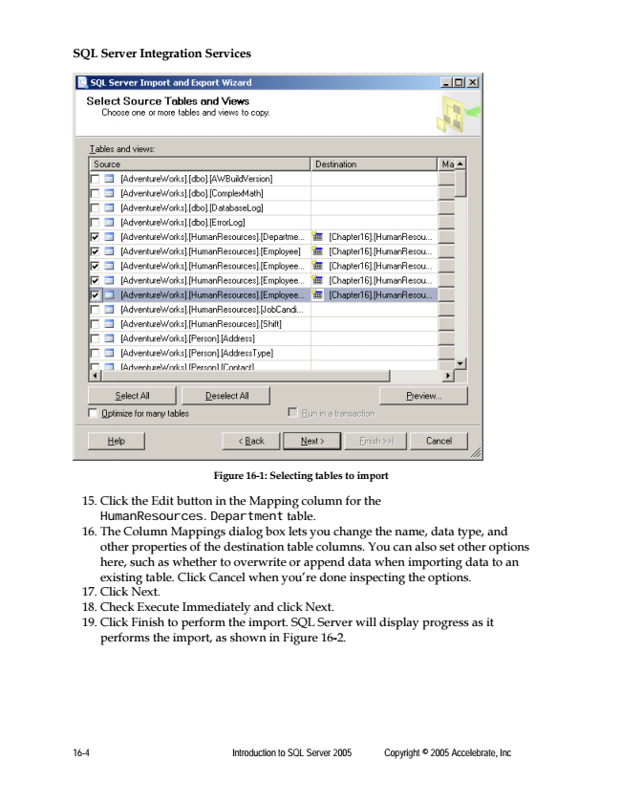

**SQL Server Integration Services**

16-4 Introduction to SQL Server 2005 Copyright © 2005 Accelebrate, Inc

**Figure 16-1: Selecting tables to import**

15. Click the Edit button in the Mapping column for the

HumanResources.Department table. 16. The Column Mappings dialog box lets you change the name, data type, and

other properties of the destination table columns. You can also set other options here, such as whether to overwrite or append data when importing data to an existing table. Click Cancel when you’re done inspecting the options. 17. Click Next. 18. Check Execute Immediately and click Next. 19. Click Finish to perform the import. SQL Server will display progress as it

performs the import, as shown in Figure 16-2.

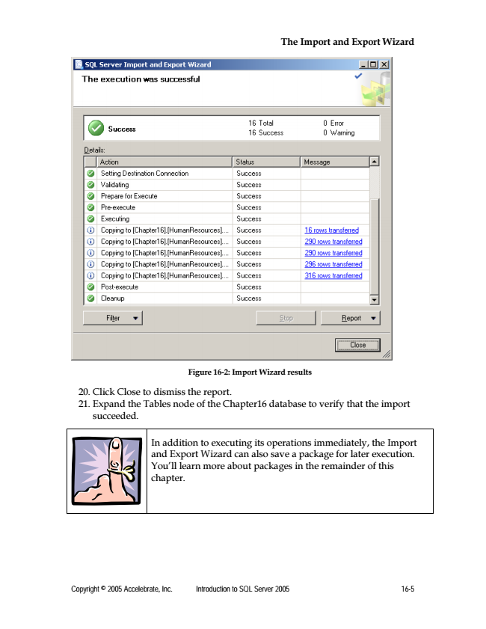

**The Import and Export Wizard**

Copyright © 2005 Accelebrate, Inc. Introduction to SQL Server 2005 16-5

**Figure 16-2: Import Wizard results**

20. Click Close to dismiss the report. 21. Expand the Tables node of the Chapter16 database to verify that the import

succeeded.

In addition to executing its operations immediately, the Import and Export Wizard can also save a package for later execution. You’ll learn more about packages in the remainder of this chapter.

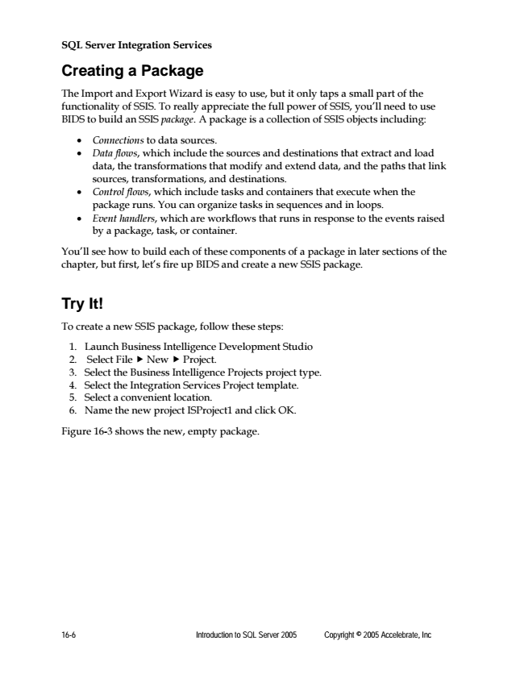

**SQL Server Integration Services**

**Creating a Package**

The Import and Export Wizard is easy to use, but it only taps a small part of the functionality of SSIS. To really appreciate the full power of SSIS, you’ll need to use BIDS to build an SSIS package. A package is a collection of SSIS objects including:

• Connections to data sources.

• Data flows, which include the sources and destinations that extract and load data, the transformations that modify and extend data, and the paths that link sources, transformations, and destinations.

• Control flows, which include tasks and containers that execute when the package runs. You can organize tasks in sequences and in loops.

• Event handlers, which are workflows that runs in response to the events raised by a package, task, or container.

You’ll see how to build each of these components of a package in later sections of the chapter, but first, let’s fire up BIDS and create a new SSIS package.

**Try It!**

To create a new SSIS package, follow these steps:

1. Launch Business Intelligence Development Studio 2. Select File ► New ► Project. 3. Select the Business Intelligence Projects project type. 4. Select the Integration Services Project template. 5. Select a convenient location. 6. Name the new project ISProject1 and click OK.

Figure 16-3 shows the new, empty package.

16-6 Introduction to SQL Server 2005 Copyright © 2005 Accelebrate, Inc

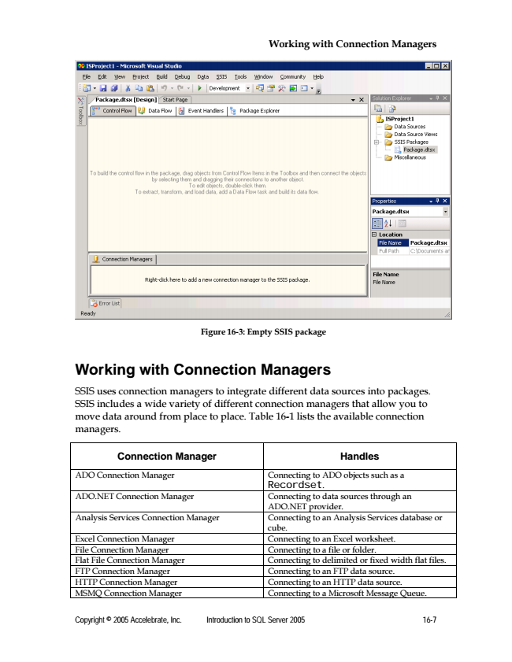

**Working with Connection Managers**

Copyright © 2005 Accelebrate, Inc. Introduction to SQL Server 2005 16-7

**Figure 16-3: Empty SSIS package**

**Working with Connection Managers**

SSIS uses connection managers to integrate different data sources into packages. SSIS includes a wide variety of different connection managers that allow you to move data around from place to place. Table 16-1 lists the available connection managers.

**Connection Manager Handles**

ADO Connection Manager Connecting to ADO objects such as a

Recordset. ADO.NET Connection Manager Connecting to data sources through an

ADO.NET provider. Analysis Services Connection Manager Connecting to an Analysis Services database or

cube. Excel Connection Manager Connecting to an Excel worksheet. File Connection Manager Connecting to a file or folder. Flat File Connection Manager Connecting to delimited or fixed width flat files. FTP Connection Manager Connecting to an FTP data source. HTTP Connection Manager Connecting to an HTTP data source. MSMQ Connection Manager Connecting to a Microsoft Message Queue.

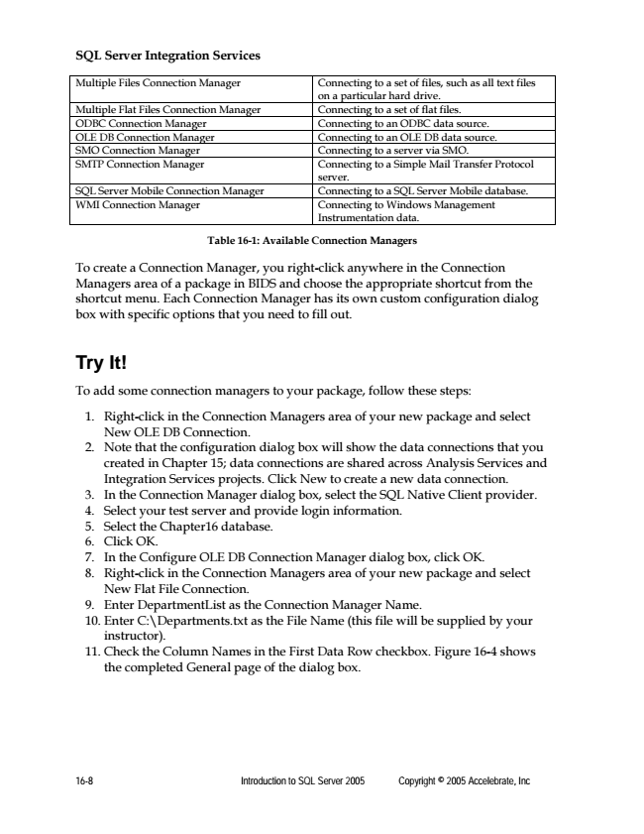

**SQL Server Integration Services**

Multiple Files Connection Manager Connecting to a set of files, such as all text files

on a particular hard drive. Multiple Flat Files Connection Manager Connecting to a set of flat files. ODBC Connection Manager Connecting to an ODBC data source. OLE DB Connection Manager Connecting to an OLE DB data source. SMO Connection Manager Connecting to a server via SMO. SMTP Connection Manager Connecting to a Simple Mail Transfer Protocol

server. SQL Server Mobile Connection Manager Connecting to a SQL Server Mobile database. WMI Connection Manager Connecting to Windows Management

Instrumentation data.

**Table 16-1: Available Connection Managers**

To create a Connection Manager, you right-click anywhere in the Connection Managers area of a package in BIDS and choose the appropriate shortcut from the shortcut menu. Each Connection Manager has its own custom configuration dialog box with specific options that you need to fill out.

**Try It!**

To add some connection managers to your package, follow these steps:

1. Right-click in the Connection Managers area of your new package and select

New OLE DB Connection. 2. Note that the configuration dialog box will show the data connections that you

created in Chapter 15; data connections are shared across Analysis Services and Integration Services projects. Click New to create a new data connection. 3. In the Connection Manager dialog box, select the SQL Native Client provider. 4. Select your test server and provide login information. 5. Select the Chapter16 database. 6. Click OK. 7. In the Configure OLE DB Connection Manager dialog box, click OK. 8. Right-click in the Connection Managers area of your new package and select

New Flat File Connection. 9. Enter DepartmentList as the Connection Manager Name. 10. Enter C:\Departments.txt as the File Name (this file will be supplied by your

instructor). 11. Check the Column Names in the First Data Row checkbox. Figure 16-4 shows

the completed General page of the dialog box.

16-8 Introduction to SQL Server 2005 Copyright © 2005 Accelebrate, Inc

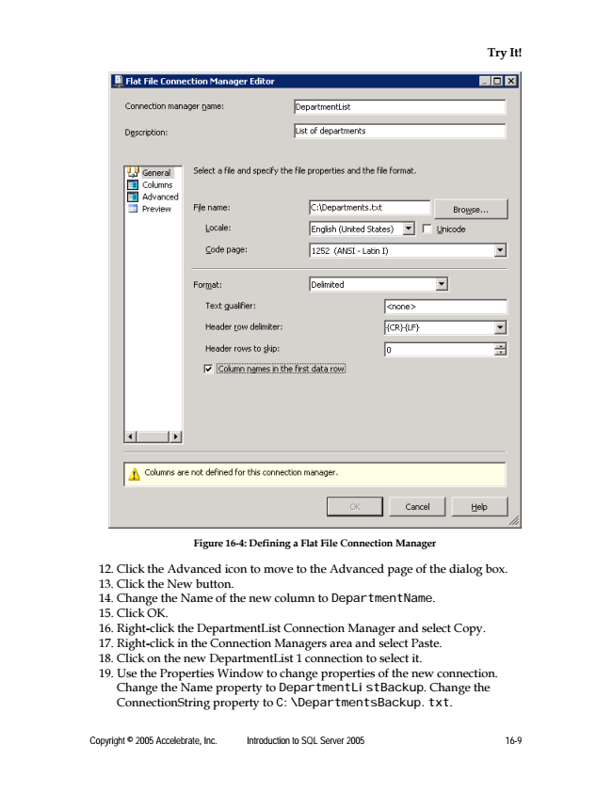

**Try It!**

**Figure 16-4: Defining a Flat File Connection Manager**

12. Click the Advanced icon to move to the Advanced page of the dialog box. 13. Click the New button. 14. Change the Name of the new column to DepartmentName. 15. Click OK. 16. Right-click the DepartmentList Connection Manager and select Copy. 17. Right-click in the Connection Managers area and select Paste. 18. Click on the new DepartmentList 1 connection to select it. 19. Use the Properties Window to change properties of the new connection.

Change the Name property to DepartmentListBackup. Change the ConnectionString property to C:\DepartmentsBackup.txt.

Copyright © 2005 Accelebrate, Inc. Introduction to SQL Server 2005 16-9

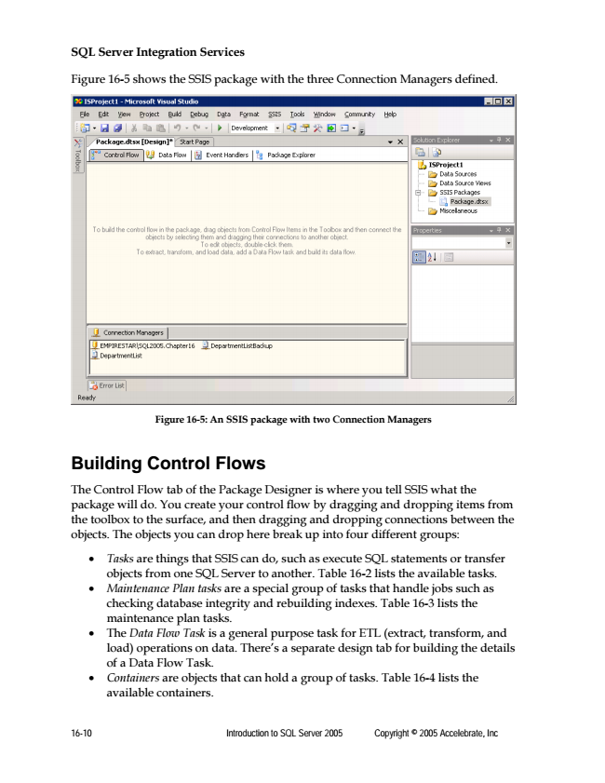

**SQL Server Integration Services**

Figure 16-5 shows the SSIS package with the three Connection Managers defined.

16-10 Introduction to SQL Server 2005 Copyright © 2005 Accelebrate, Inc

**Figure 16-5: An SSIS package with two Connection Managers**

**Building Control Flows**

The Control Flow tab of the Package Designer is where you tell SSIS what the package will do. You create your control flow by dragging and dropping items from the toolbox to the surface, and then dragging and dropping connections between the objects. The objects you can drop here break up into four different groups:

• Tasks are things that SSIS can do, such as execute SQL statements or transfer objects from one SQL Server to another. Table 16-2 lists the available tasks.

• Maintenance Plan tasks are a special group of tasks that handle jobs such as checking database integrity and rebuilding indexes. Table 16-3 lists the maintenance plan tasks.

• The Data Flow Task is a general purpose task for ETL (extract, transform, and load) operations on data. There’s a separate design tab for building the details of a Data Flow Task.

• Containers are objects that can hold a group of tasks. Table 16-4 lists the available containers.